|  |
| --- |
| Creating Web Application |
| COS10011  Semester 1, 2022 |
|  |
|  |
|  |

|  |  |
| --- | --- |
| Member Name | Member ID |
| Nicholas Ting Tiew Leong | 102767857 |

Table of Contents

1.0 Introduction 3

1.1 Scope of the website 3

1.2 Intended audience 3

2.0 Web page Design and Structure 3

2.1 Website Layout Mock ups 3

2.2 Website Structure 8

3.0 End Product 9

3.1 Actual User Interface 9

3.1.1 Main Page 9

3.1.2 Service Pages 11

3.1.3 About Me Page 14

3.1.4 Enquiry Page 15

3.1.5 Disclaimer Page 16

3.1.6 Acknowledgement Page 17

3.1.7 Enhancement Page 18

3.2 Enhancements 19

3.2.1 Drop-down Menu 19

3.2.2 Google Maps 20

3.2.3 Image Slider 21

3.2.4 Tooltip 21

3.2.5 YouTube Video 22

**Assignment 1**

# 1.0 Introduction

## 1.1 Scope of the website

The scope of this website consists of giving the user useful information about Dota 2. For example, the users are able to acknowledge and take a closer look at the game itself by surfing through the service pages which contain much of the descriptions of the game. The users may also express their feelings or questions about the game by dropping their comment in the enquiry page.

## 1.2 Intended audience

The intended audience is for everyone, new or passionate gaming players who visit game web pages on their regular basis. With people who love playing online games, anyone who enters the web page are able to reap the benefits of obtaining game services and embark on their journey towards the multiple online battle arena and experience the community plus the entertaining features embedded within the game.

# 2.0 Web page Design and Structure

## 

## 2.1 Website Layout Mock ups

Wireframe for Main Page (Index Page).

Navigation Bar

Logo

Image Slider

Footer

Wireframe for Service Pages (Home, Heroes, Updates, Esports)

*Home*

Navigation Bar

Logo

Title

YouTube Video

Description

Footer

*Heroes, Updates, Esports*

Navigation Bar

Logo

Content Info

Content Image

Content Info

Content Image

Content Info

Content Image

Content Info

Content Image

Footer

Wireframe for Profile Page

Navigation Bar

Logo

Profile Picture

Profile Info

Google Maps

Footer

Wireframe for Enquiry page

Navigation Bar

Logo

Personal Details

Address

Other Info

Reset

Submit

Footer

Wireframe for Disclaimer page

Navigation Bar

Logo

Disclaimer content

Footer

Wireframe for Acknowledgement page

Navigation Bar

Logo

Service1 Links

Service2 Links

Service3 Links

Service4 Links

Footer

Wireframe for Enhancement page

Navigation Bar

Logo

Enhancement 1

Enhancement 2

Enhancement 3

Enhancement 4

Footer

## 2.2 Website Structure

index.html

enhancement.html

aboutme.html

disclaimer.html

home.html

characters.html

acknowledgement.html

enquiry.html

updates.html

esports.html

# 3.0 End Product

## 3.1 Actual User Interface

## **3.1.1 Main Page**

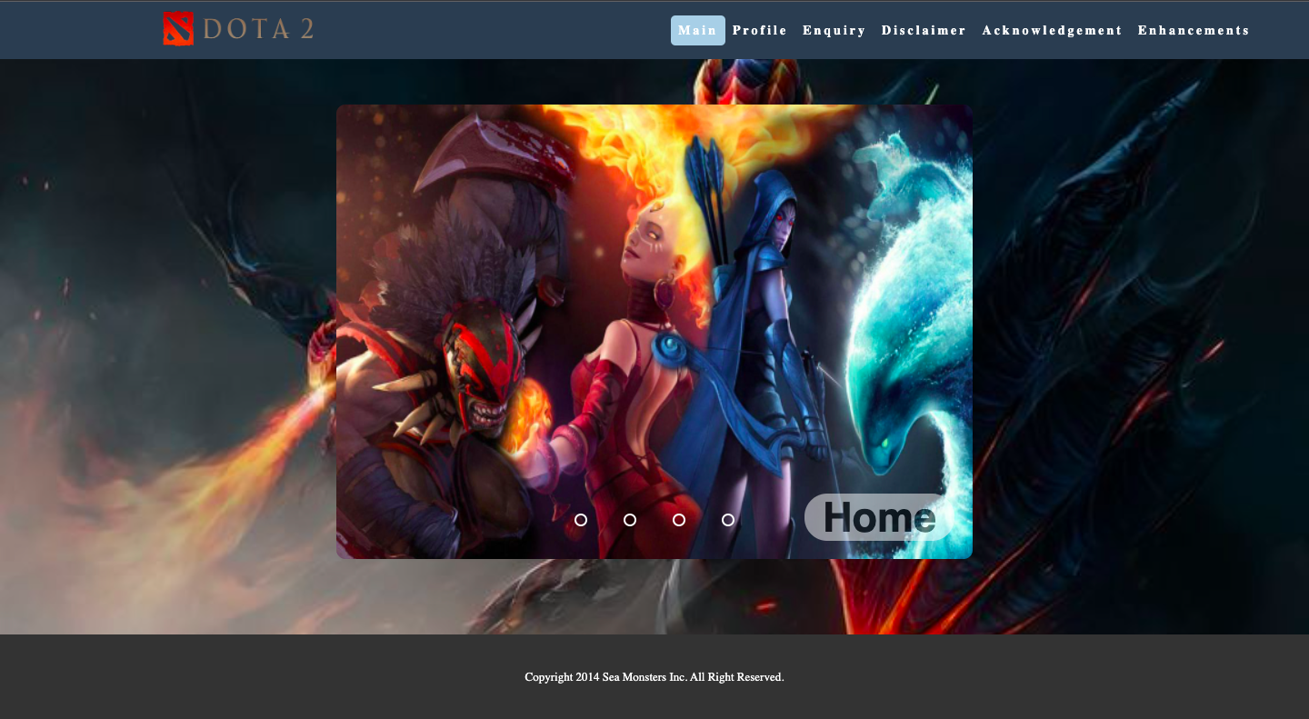

Upon clicking on the website, the user will be greeted by the main page of our website. The main page is basically the introduction to the service page”. There is a image slider which displays the four service pages of the website. This allows the users to access the four pages quickly, without scrolling vertically or using the mouse.

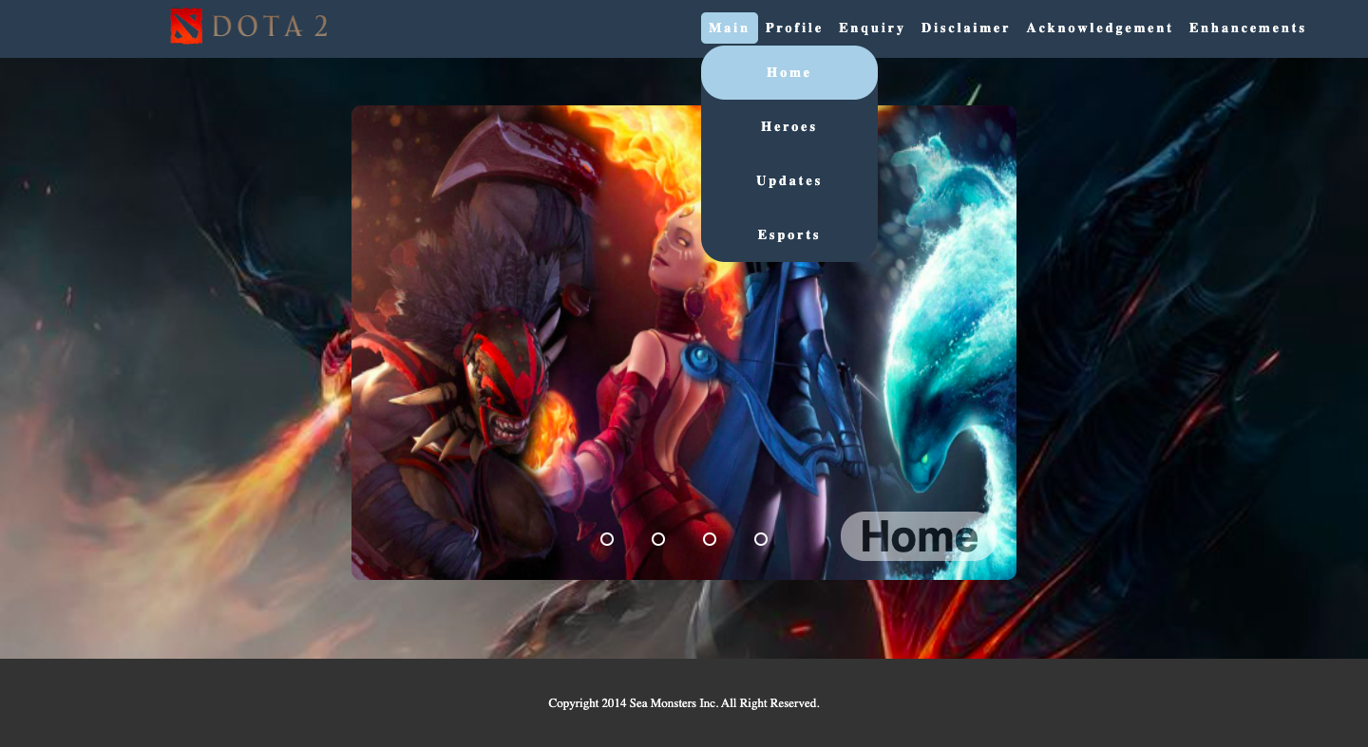

At the bottom right corner, there is a name of each service pages that is embedded in four image slides respectively to make the website look more attractive. With that said, the users are able to have access to four of these service pages by clicking on the main page button at the navigation bar which will activate a drop-down menu. Within the drop-down menu, it consist of the four service pages which can save the users time by allowing them to jump down a level or two to get to the content they seek.

### 3.1.2 Service Pages

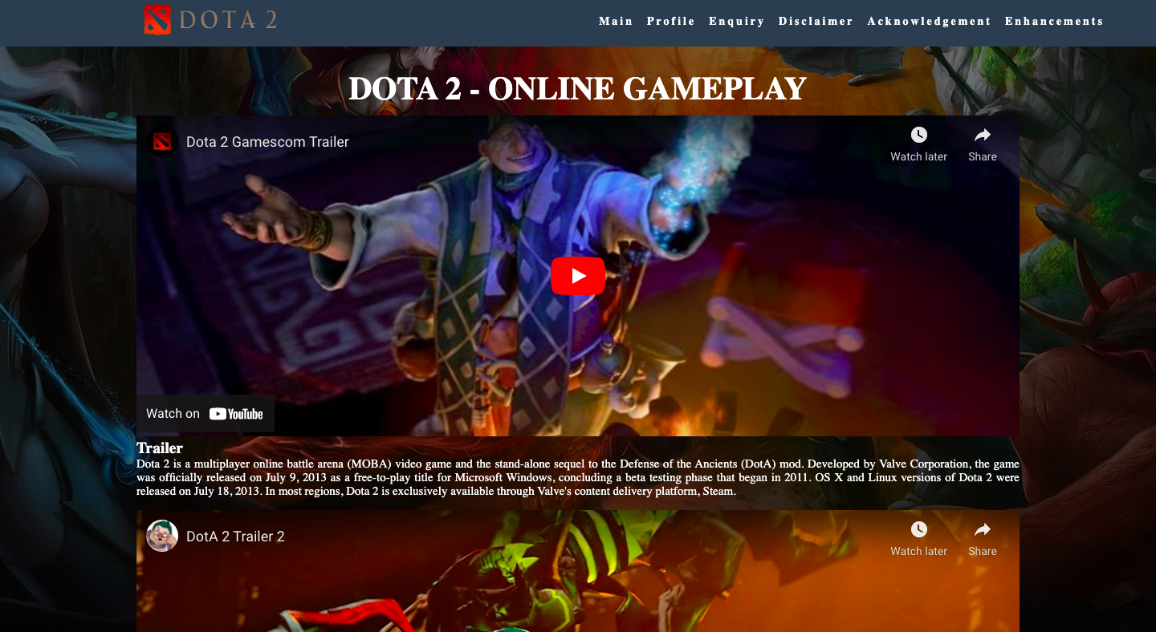

Each and every single one of the product pages which are “Home”, ”Heroes”, “Updates” and “Esports” displays the main contents of the web page. The home page has a different way of showcasing contents as it introduces the Dota2 game in YouTube video formats while the other three pages shares identical formatting and style. With the display of videos, users do not have to fiddle around trying to get the video to play on their device, and they do not have to jump through a lot of hoops to show it to other people. Plus, users do not have to worry about “suggested videos” that are appended to the end of the videos which may improve the quality of the videos while they were being played.

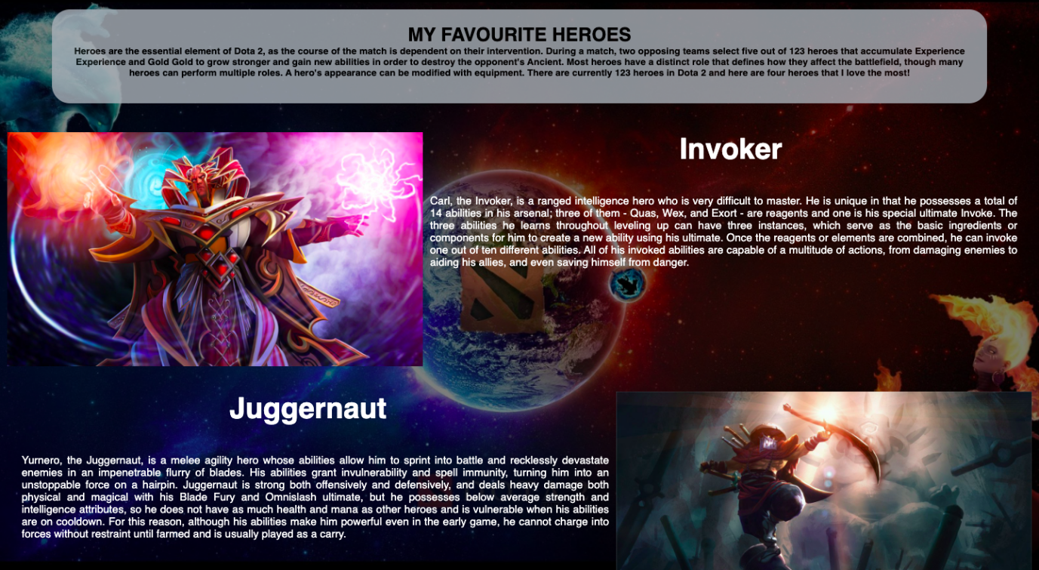

The three other service pages have similar design and content outputs which is in the form of displaying the content images on the left and the content’s description on the right. The format for the upcoming content will alter reversely by changing the sides of images and description. In the “Heroes” page, it showcased four heroes or characters of the game which the webmaster favor the most. With this design, users may able to recognize and have an insight in the heroes of the game.

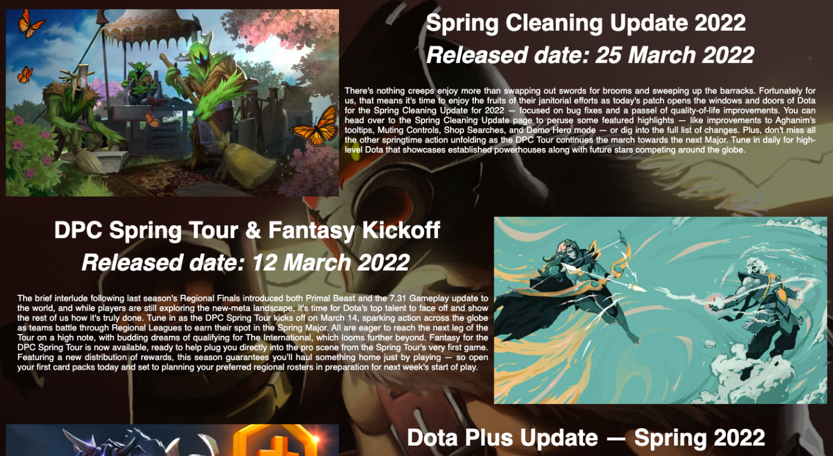

On the other hand, the “Updates” page will showcase the recent updates or news of the game. This may allow the users to receive valid information and gain a deeper understanding towards the game itself.

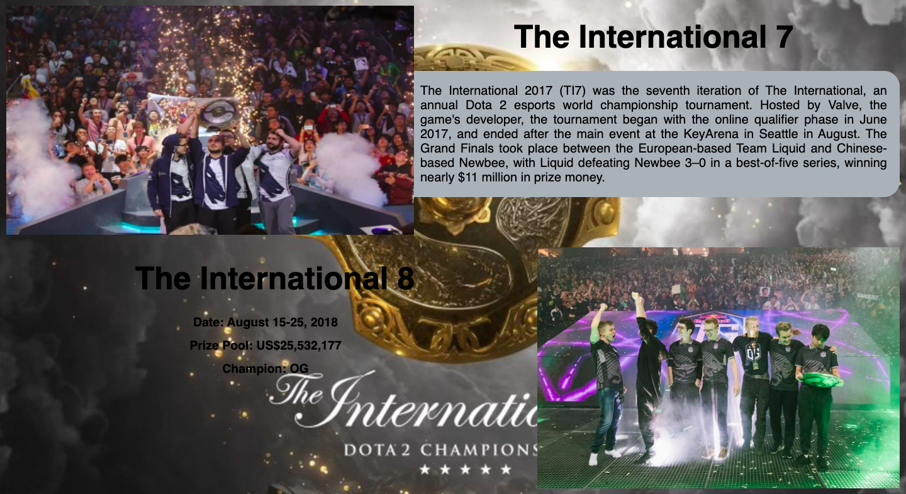

Lastly, the “Esports” page exhibits the greatest events that ever been organized by the game. Thus, this motivates and attracts users to play the game and celebrate these wonderful events and championships along with the other Dota2 fans around the world.

### 3.1.3 About Me Page

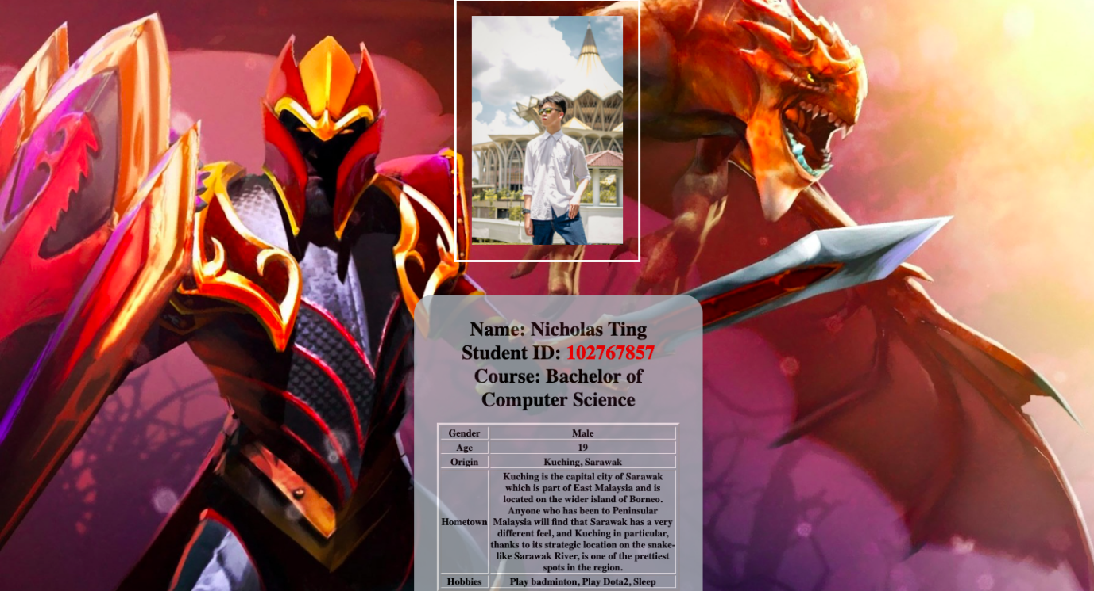

The about me page which is the profile page displays the personal information of the webmaster. It displays the webmaster’s name, student ID, course taking, gender, age, origin, hometown description, hobbies, the location of the webmaster’s university as well as the webmaster’s contact information.

### 3.1.4 Enquiry Page

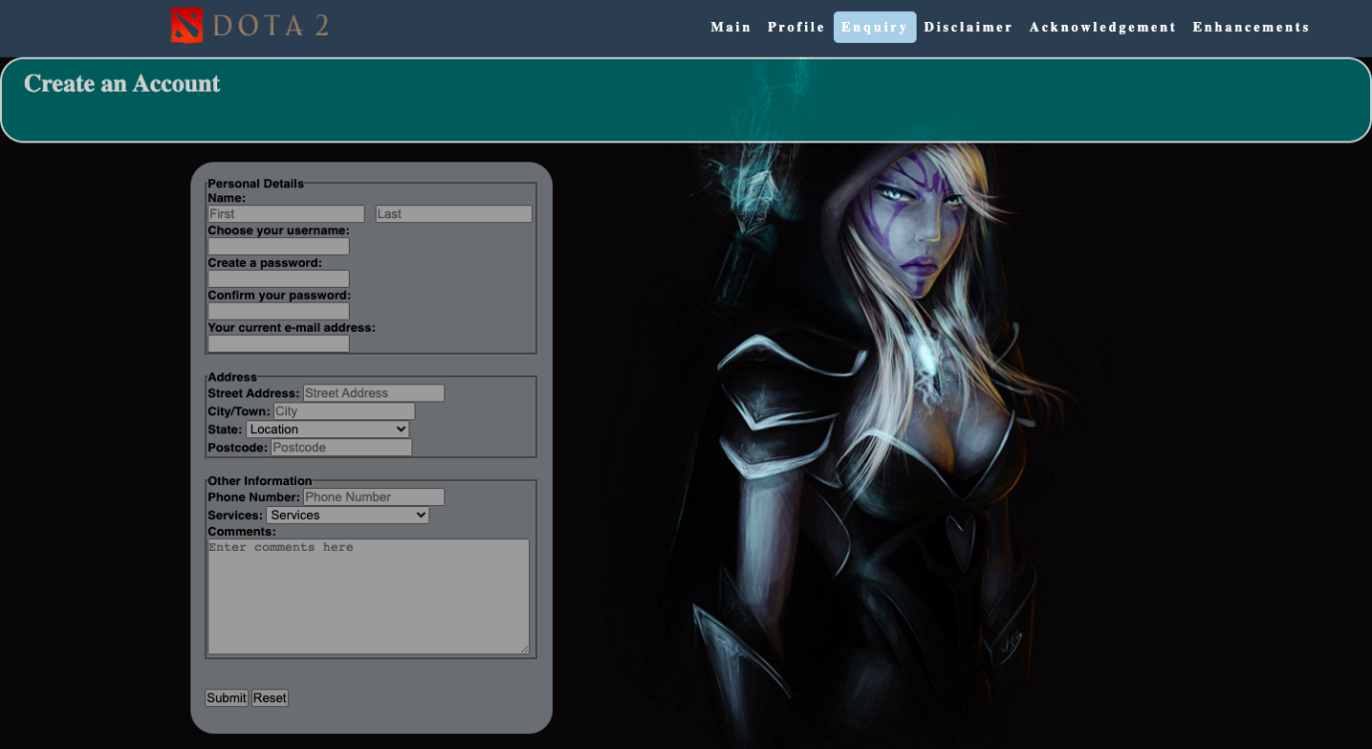

The enquiry page is where the users enter and create their own account to proceed them into the game. However, in order to do so, they must fill in the form shown in the enquiry page first. Starting from their personal details requesting for their first and last name, username, password and email. Secondly, the next field requires the user to fill in their address information such as street address, city or town, state as well as their postcode. For further information, the user must enter their phone numbers and there is a drop box which lets the user select the services that they would like to enquire and write down their thoughts and opinions about it in the comment section box. Last but not least, the user can submit the details that they have just keyed in by clicking on the submit button but if they have second thoughts and would like to cancel the submission they can always press the reset button to wipe out everything that they have filled in.

### 3.1.5 Disclaimer Page

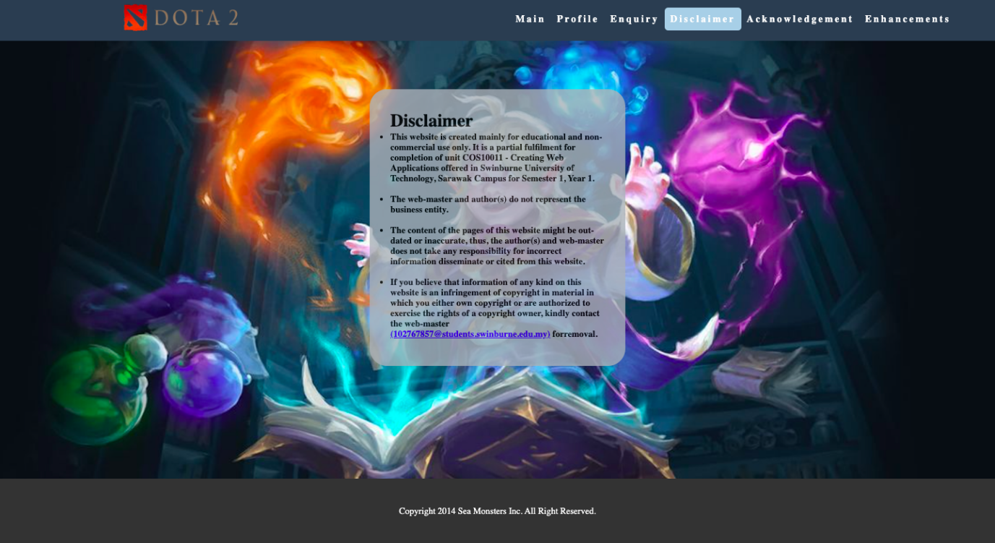

Moreover, The disclaimer page is where the webmaster write the official statements to ensure our website is safe from legal liability. The disclaimer page acts as a notice symbol whenever users come and visit our website. It notifies them that our products do not represent the business entity and the information might be copyrighted.

### 3.1.6 Acknowledgement Page

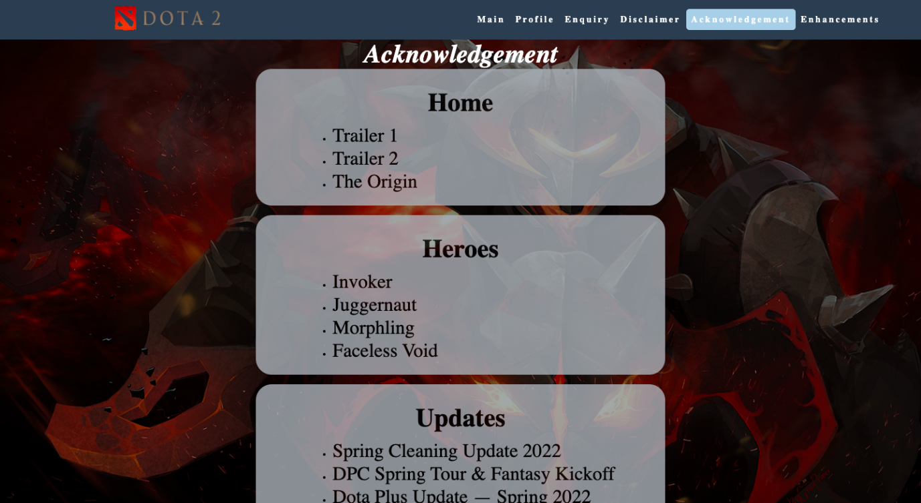

The acknowledegment page provides the links of the contents within the four service pages. This page acts as a reference page for users so that they can gain more information of the contents that were being displayed in each service pages with ease and conveniently.

### 3.1.7 Enhancement Page

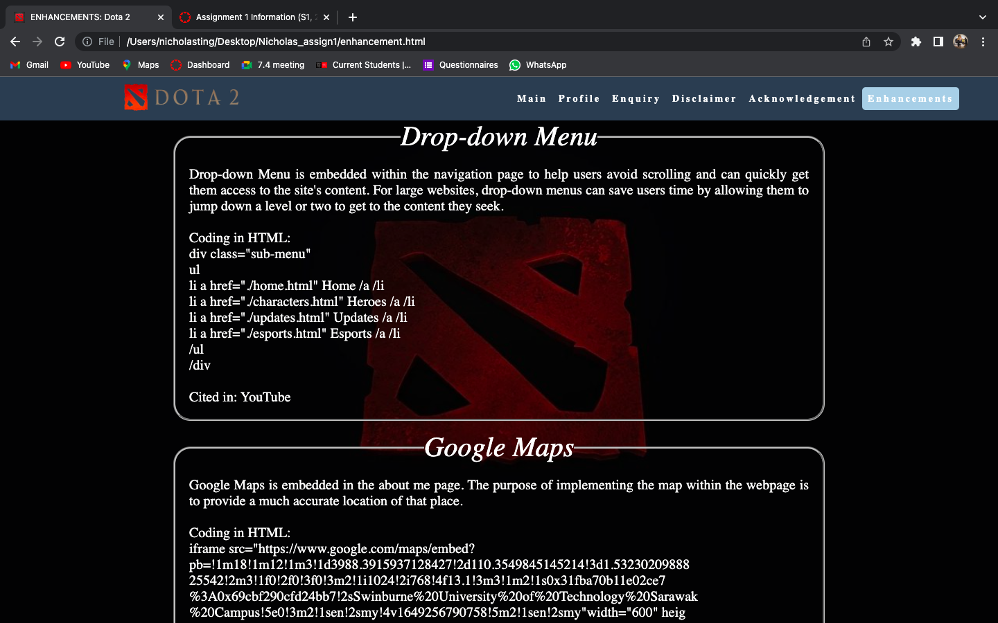

Lastly, the enhancement page shows the user what the webmaster did in order to improve the website to make it look more attractive and user-friendly so that it does not overwhelm the user.

## 3.2 Enhancements

### 3.2.1.1 Drop-down Menu



Drop-down Menu is embedded within the navigation page to help users avoid scrolling and can quickly get them access to the site's content. For large websites, drop-down menus can save users time by allowing them to jump down a level or two to get to the content they seek.

### 3.2.1.2 Google Maps

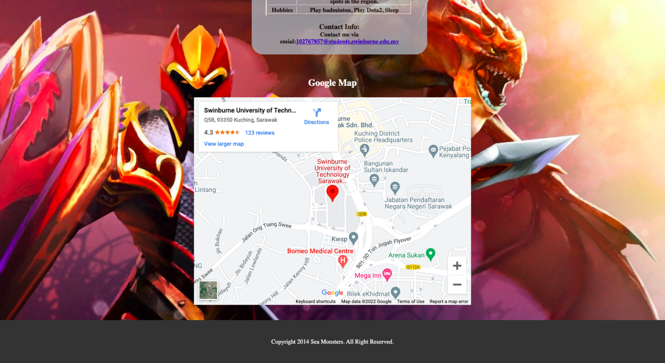

Google Maps is embedded in the about me page. The purpose of implementing the map within the webpage is to provide a much accurate location of that place.

### 3.2.1.3 Image Slider



Image Slider is embedded at the index page to showcase images which can show much more information and save more space than on a printing document. It allows users to access the information quickly, without scrolling vertically or using the mouse.

### 3.2.1.4 Tooltip



Tooltip is embedded at the esports page to highlight new features inside the platform without interrupting the user's workflow. Unlike pop-ups, tooltips are a non-intrusive and efficient way to promote new features since they draw user's attention while providing additional information next to the feature itself.

### 3.2.1.5 YouTube Video



YouTube Video is embedded at the home page to makes it easier for others to view, use, and share the videos. Users don’t have to fiddle around trying to get the video to play on their device, and they don’t have to jump through a lot of hoops to show it to other people.

**Assignment 2**

## 1.0 Description

This assignment extends the previous assignment website by adding a link, button or an icon to each product or service offered by the website. This link would ease users to send an inquiry regarding a certain product and all inquiry information must be validated before it can be submitted successfully. In short, this assignment must be implemented with JavaScript and its functions to validate forms, apply client-side storage to transfer data between pages and within a page, provide user feedback and accomplish various types of enhancements.

JavaScript Code:

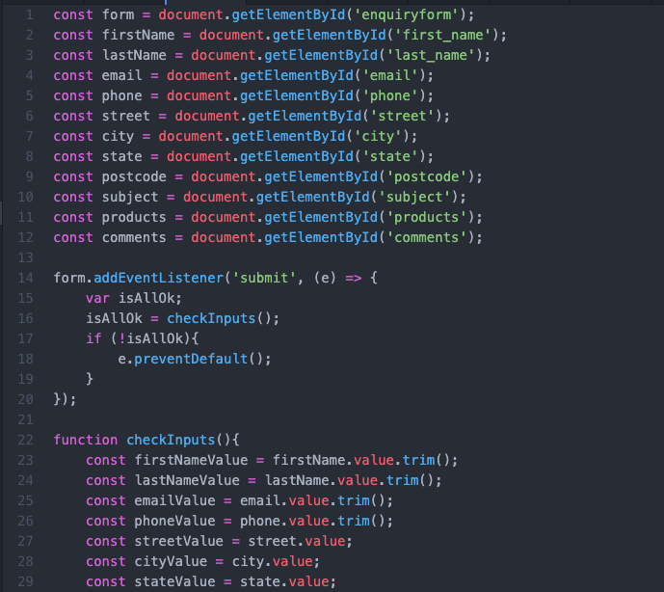

For instance, the code above briefly showcase the primary and basic validations. First of all, the form must be checked to make sure all the mandatory fields are filled in. It would require just a loop through each field in the form and check for data. Secondly, the data that is entered must be checked for correct form and value by implementing functions on the data formats for each field.

## 1.1 Data Transfer between pages

The enquiry page of the webpage will include another input field called “Subject” input field and this page must be accessible from any page where a product or service is displayed. An enquire button at each product will be formed and when clicked it will redirect the user to the enquiry page and the “Subject” input field will be pre-filled with the relevant product name and description.

JavaScript Code:

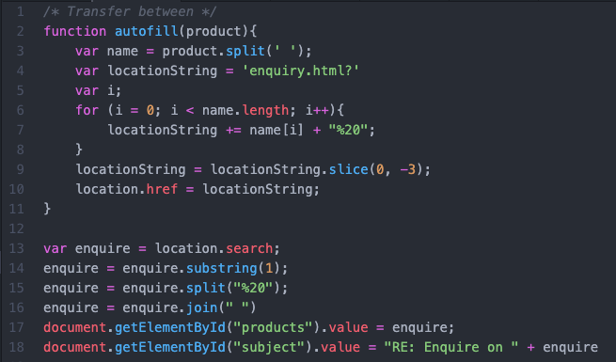

## 1.2 Data Transfer within the page

Additionally, users are able to navigate to the enquiry page without first selecting a particular product. Therefore, by adding JavaScript codes, the page will be automatically filled with the “Subject” input field each time the user selects a product from the “Service” input field of the existing form.

JavaScript Code:

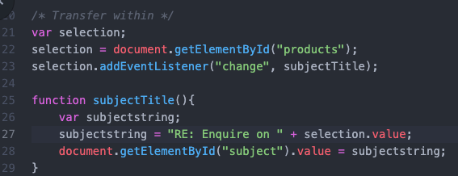

## 1.3 Populate drop down listing into array

The products or services within the drop down list inside the enquiry page will be stored by creating an array in JavaScript. An array (values) can be accessed using index (key) and it also includes "length" property which returns number of elements in the array.

JavaScript code:

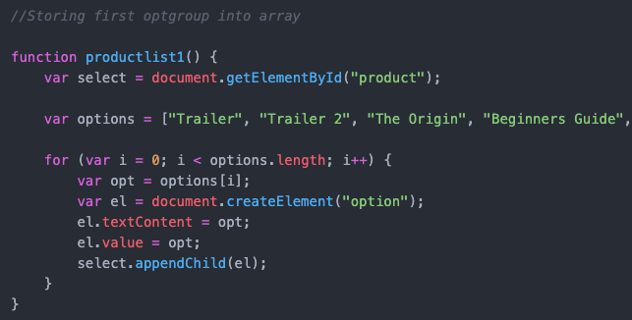

## 2.0 End Product

## 2.1 Enhancements

## 2.1.1 Back-to-top Button

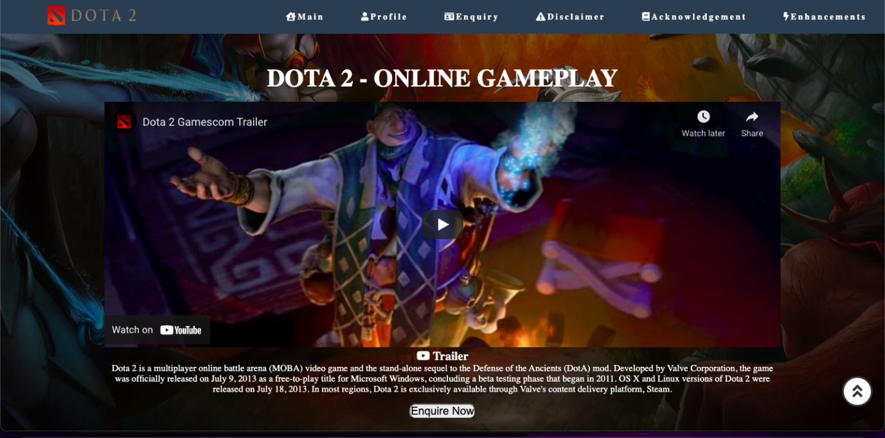

At the Main page, 4 service pages and Enquiry page, it will show the back to top button with an animation fading up for 3 seconds in the lower right corner of the page which the button itself is a double arrow in a circle, When hovering over the back to top button ,the color of the button itself will change. When the back to top button is clicked, the page will scroll to the top of the page itself.

## 2.1.2 Auto Navigation in Image Slider

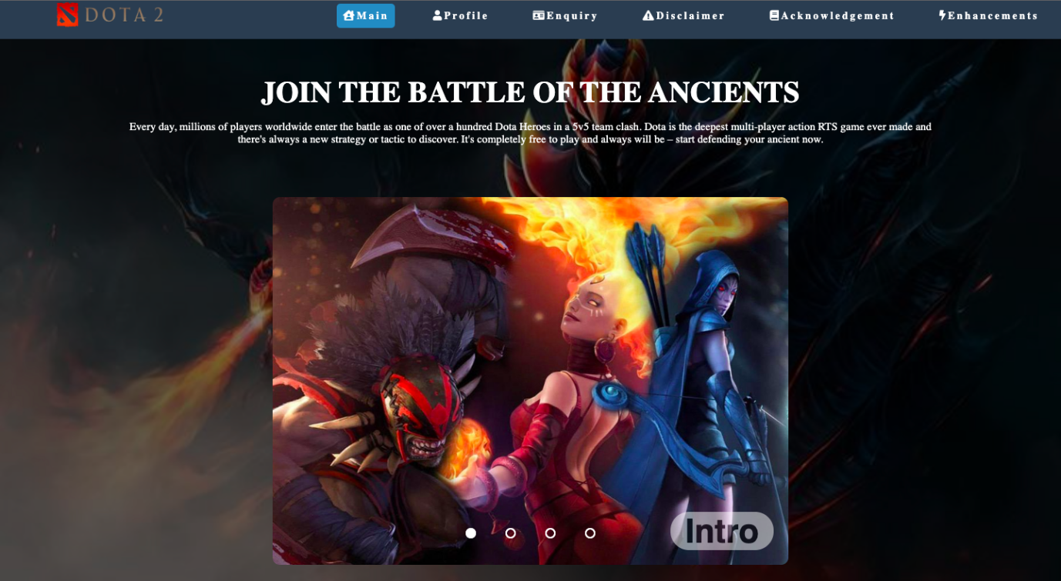

The image slider which is implemented in the main page have been upgraded using javascript. It allows the slider to slide automatically without the users' interaction. Every image will change after every four seconds and users are still able to click on the slider manually.

## 2.1.3 Hamburger Navigation

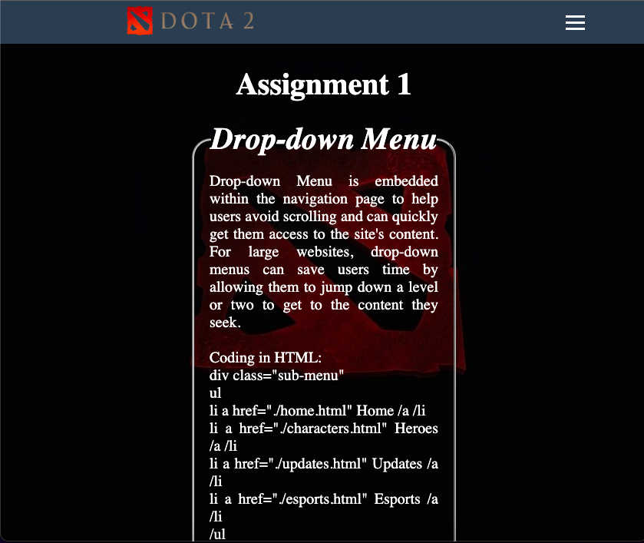

As the screen size reaches 1300px and the navigation bar cannot display the links properly, the links will be replaced with a burger which is the three lines shown above using the @media screen and (max-width: 1300px) property and display none for the links and display block for the burger. The links are styled to align vertically with a background color then push out of the window screen using position absolute right 0px and the body overflow is hidden. When clicking on the burger button, it will listen to the burger click and then display the navigation links as shown in the picture above.

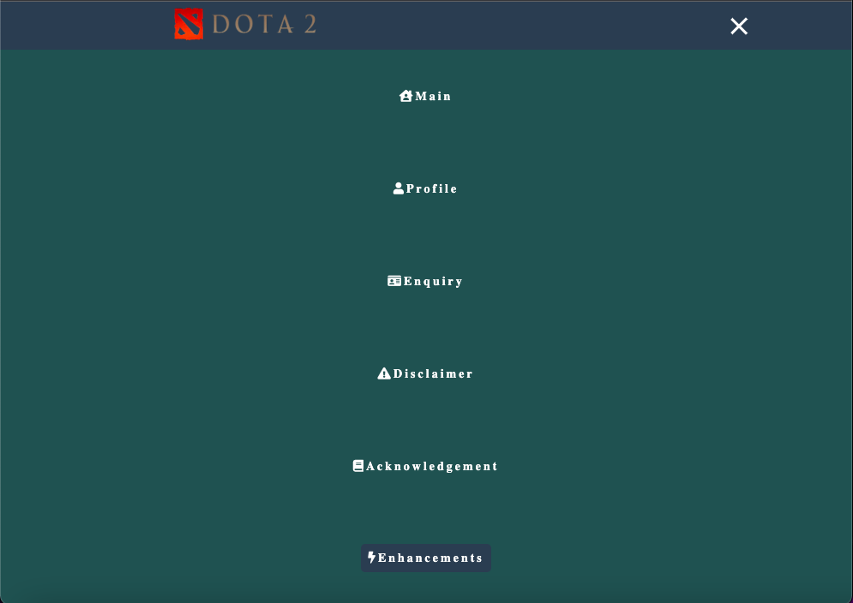

Not only the burger will be transformed into a cross using the transform method, the nav-links will also appear.

## 2.1.4 Digital Clock

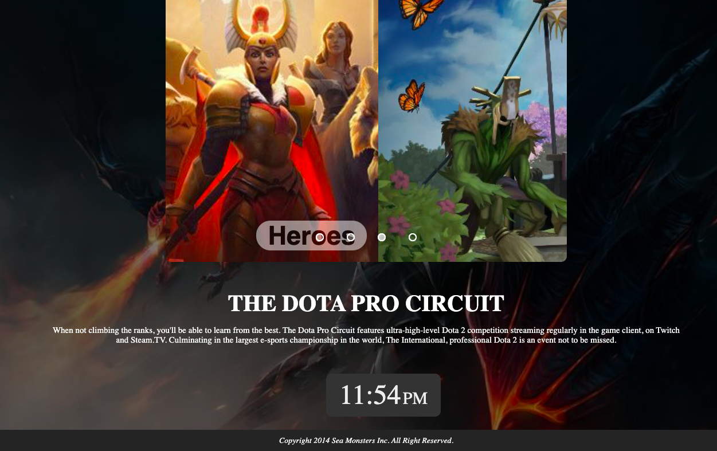

Live digital clock is embedded in most of the html pages. The clock works by implementing various functions regarding the time of the clock in a file called clock.js which is located in the script folder. This will ease the users as they will be notified by the actual time when surfing through the webpages.

## 2.1.5 Data Transfer Simultaneously

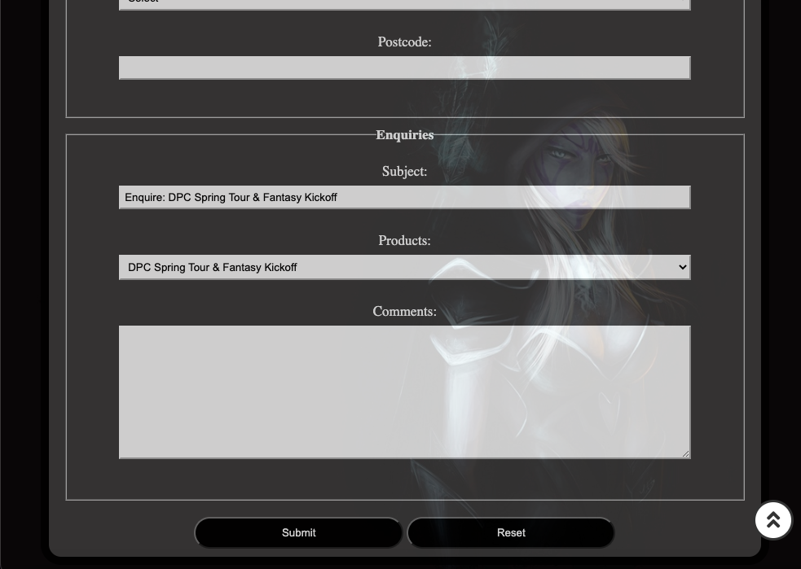

The function for this simultaneous data transferring is located in transfer.js in the script folder. This allows the users to speed up their enquiry process as it will automatically fill the subject field and the product field simultaneously with whichever product that the user had enquired from other product pages.

**Assignment 3**

**1.0 Description**

In this assignment, the website that was developed in Assignments 1 and 2 will be enhanced by using PHP and storing the server-side information in MySQL database. It will involve the creation of MySQL tables to store, update and retrieve information from a website using mysqli commands. This information would have been collected through the previous HTML forms.

For instance, PHP include statements is used in this assignment. It takes all the texts, codes and markups that exists in a specified file and copies it into the file that uses the include statement. As an example, if a footer is needed to be applied to all pages, then simply add <?php include 'footer.php';?> to any pages that was desired whereby the footer itself have its own file which contains the code as below:

<?php

echo "<footer>";

echo "<p>Copyright 2014 Sea Monsters Inc. All Right Reserved.</p>";

echo "</footer>";

?>

For MySQL, it is implemented so that users’ data will be stored within a table in a database created by MySQL. First, MySQL operates when one or more users connect to a server through a specific network. Every users can make a request from the graphical user interface (GUI) on their screens, and the server will produce the desired output, as long as both ends understand the instruction. The main processes were taking place in a MySQL environment are the same. MySQL creates a database for storing and manipulating data, defining the relationship of each table. Users are able to make requests by typing specific SQL statements on MySQL. The server application will respond with the requested information and it will appear on the users’ side.

**1.1 Essential Specified Requirements**

**1.1.1 PHP**

PHP provides the techniques to modularise and reuse our web application scripts in this assignment. For example, the common elements within a web page such as the navigation and footer will be re-written from html pages so that static HTML elements common to the pages are sourced from the same PHP scripts.

The PHP include statements for the navigation and footer is created in two different files and both of them are added to all of the web pages by simply using the include statement, <?php include 'footer.php';?> for footer and <?php include 'navigation.php';?> for navigation respectively.

**1.1.2 Database Table**

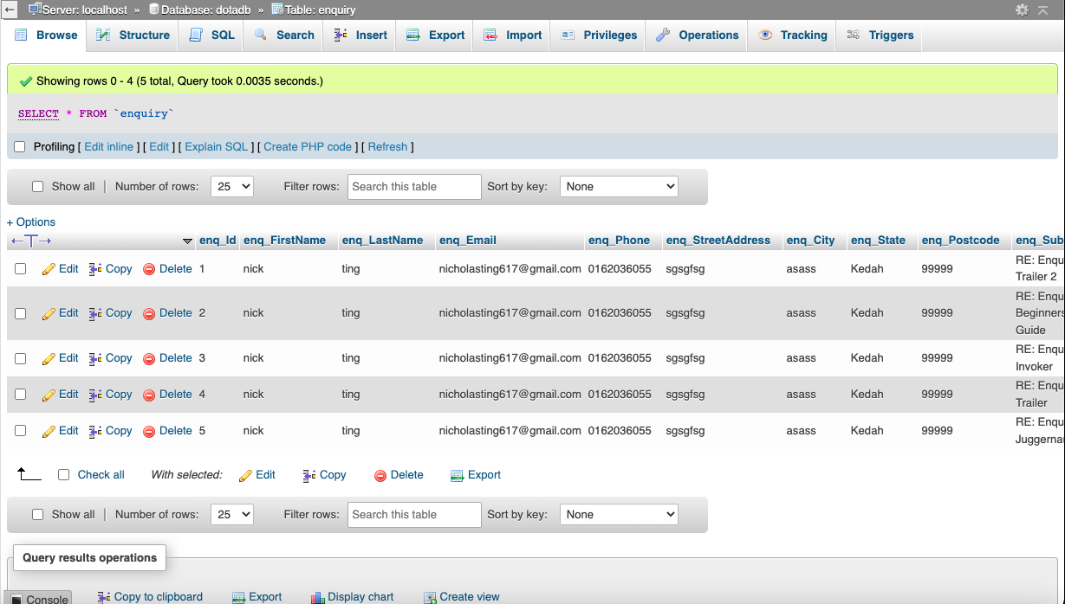

An "enquiry" table on a MySQL database is created which will record the enquiry sent by the potential customers via the enquiry.html. The data type of each field and column of this table is being matched with the appropriate validation rules from the previous assignment.

**1.1.3 Enquiry Submission (enquiry_process.php)**

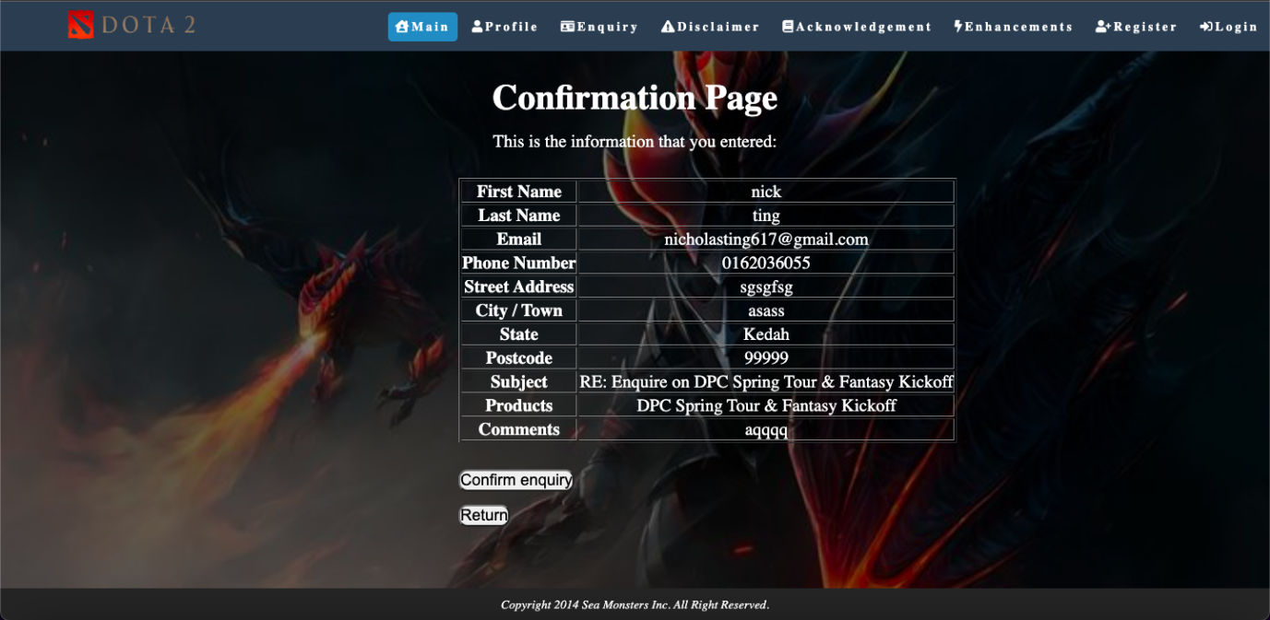

In this section, the enquiry.html web page that was coded in Assignment 2 is renamed to enquiry.php. This form have a submit button that will sent the enquiry data to the server where it is processed by enquiry_process.php and stored in the enquiry table after it was clicked.

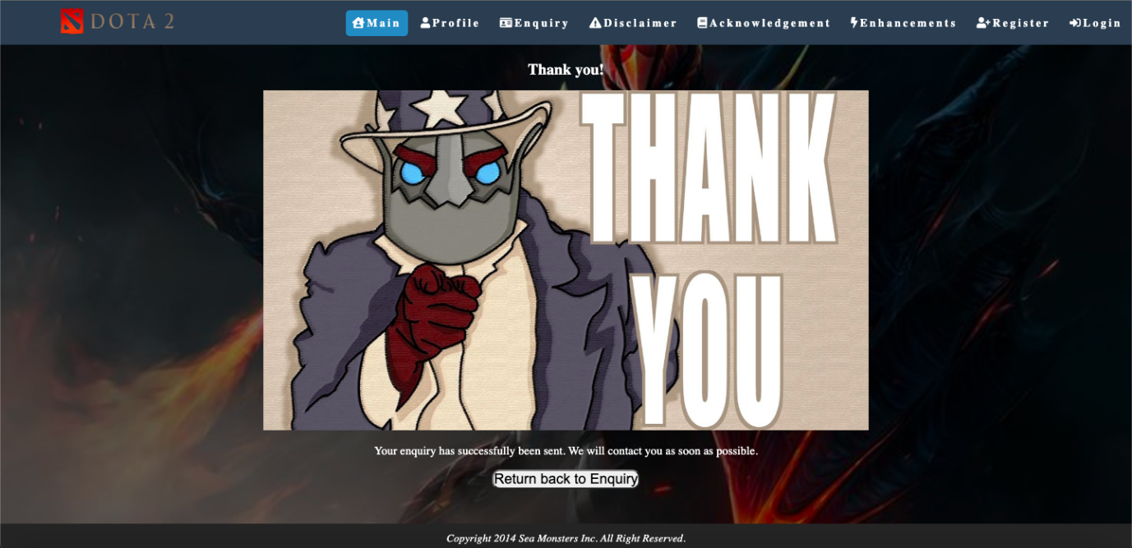

The enquiry_process.php page will display the confirmation message to inform the user that the data has been successfully saved to the database. This message is being coded in a file called confirm.php.

**1.1.4 View enquiries (view_enquiries.php)**

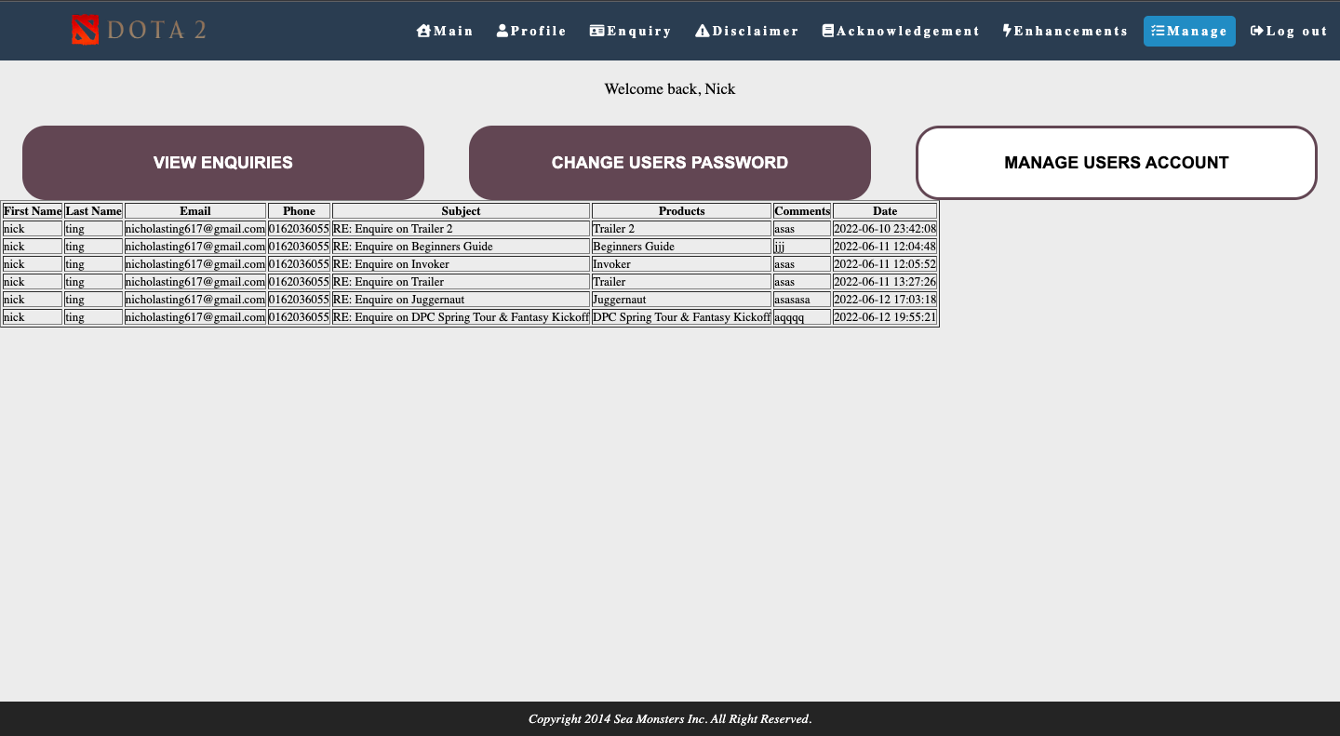

The website allows the owner to view all enquiries submitted by the users. To achieve this, another page called view_enquiries.php is created. This page retrieves all the enquiry data from MySQL database and display them in a proper manner. These will be accessible after the users have logged into the website through the register page and login page as shown below.

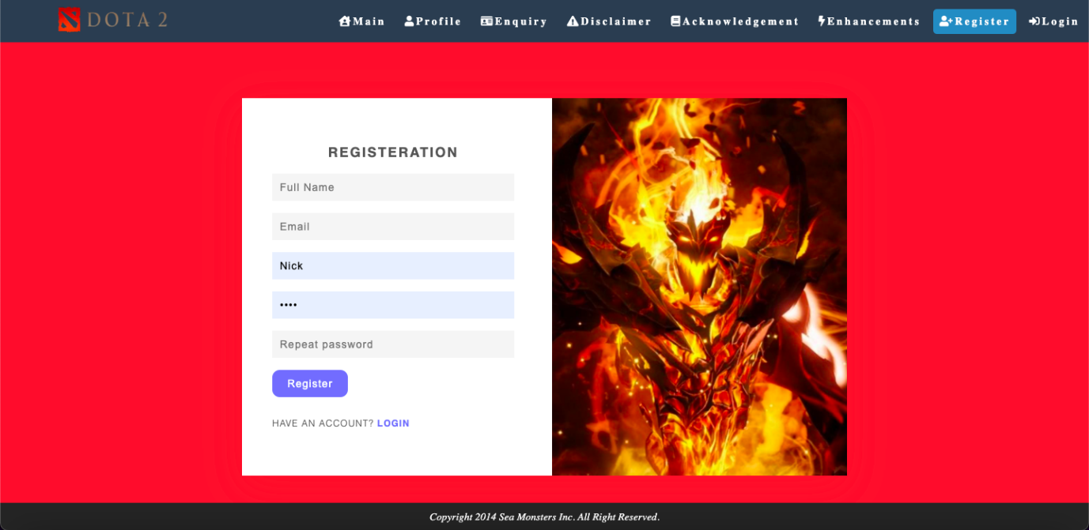

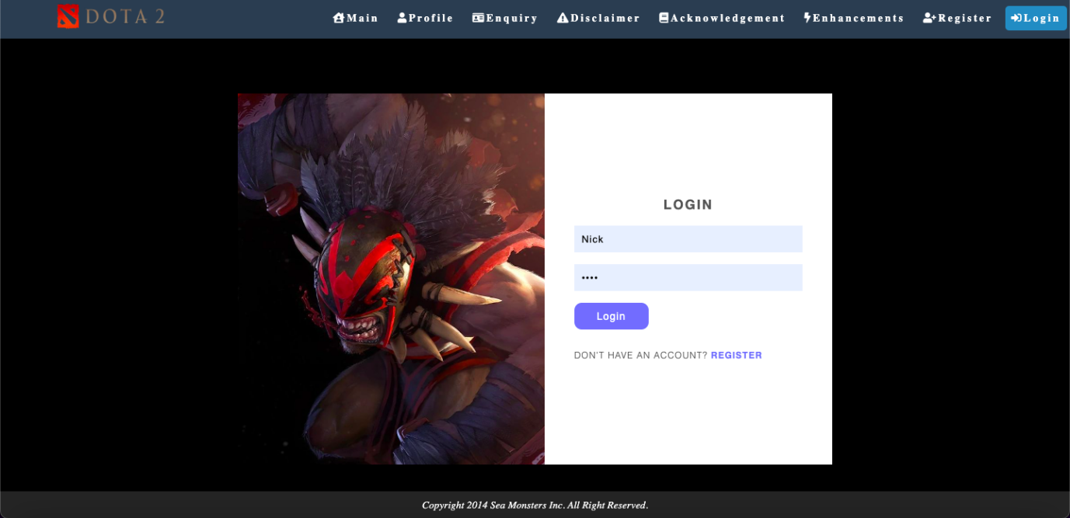

By implementing the functions that were coded in the includes folder, the system will work as fine and the data will be sent and stored in a new table categorized for users at the MySQL database as shown below.

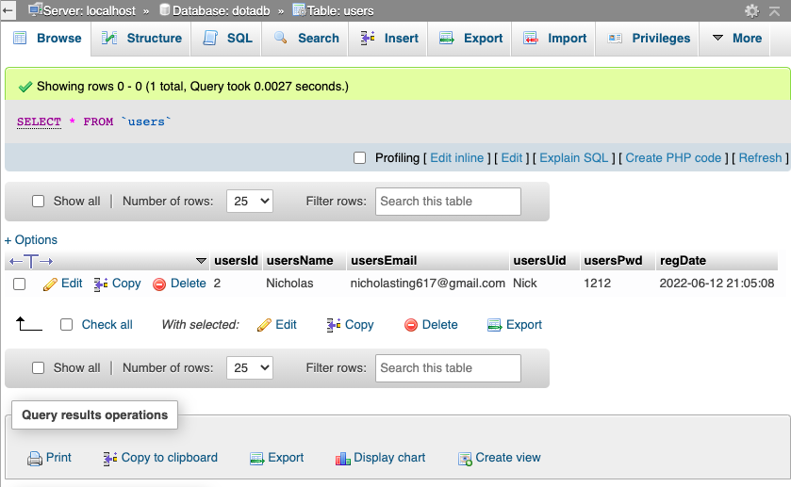

**2.0 MySQL Database Structure**

**2.1 Enquiry Table**

|  |  |
| --- | --- |
| **Name** | **Data Type** |
| **ID** | **INT(11) UNSIGNED NOT NULL AUTO_INCREMENT PRIMARY KEY** |
| **First_name** | **VARCHAR(128) NOT NULL** |
| **Last_name** | **VARCHAR(128) NOT NULL** |
| **Email** | **VARCHAR(128) NOT NULL** |
| **Phone** | **VARCHAR(128) NOT NULL** |
| **Street Address** | **VARCHAR(128) NOT NULL** |
| **City** | **VARCHAR(128) NOT NULL** |
| **State** | **VARCHAR(128) NOT NULL** |
| **Postcode** | **VARCHAR(128) NOT NULL** |
| **Subject** | **VARCHAR(128) NOT NULL** |
| **Products** | **VARCHAR(128) NOT NULL** |
| **Comments** | **VARCHAR(128) NOT NULL** |
| **Date** | **TIMESTAMP** |

**2.2 User Management Table**

|  |  |
| --- | --- |
| **Users ID** | **INT(11) UNSIGNED NOT NULL AUTO_INCREMENT PRIMARY KEY** |
| **Users Name** | **VARCHAR(128) NOT NULL** |
| **Users Email** | **VARCHAR(128) NOT NULL** |
| **Users UID** | **VARCHAR(128) NOT NULL** |
| **Users Password** | **VARCHAR(128) NOT NULL** |
| **Register Date** | **TIMESTAMP** |

**3.0 End Product**

**3.1 Enhancement (User Management Module)**

In this segment, the website is enhanced by adding and implementing user authentication features for the web owner or the admin of the website to view and manage the public enquiry. They are capable of creating, viewing, editing and deleting users from the website. Within this module, a new table for users is created in MySQL database. For that, more PHP forms and pages will be created for those purposes.

**3.1.1 Editing**

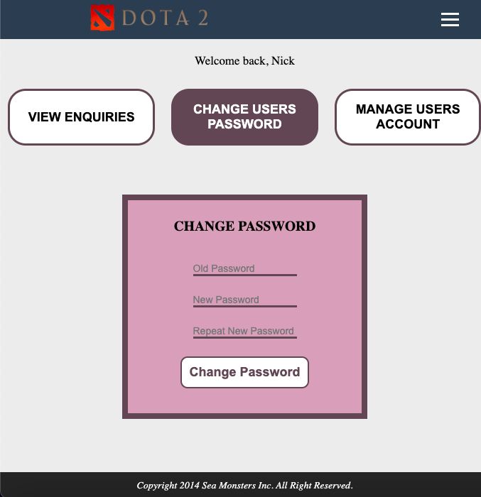

With the file called change_password.php, users who logged into the web page will have the opportunity to edit their data which in this case is by changing their password.

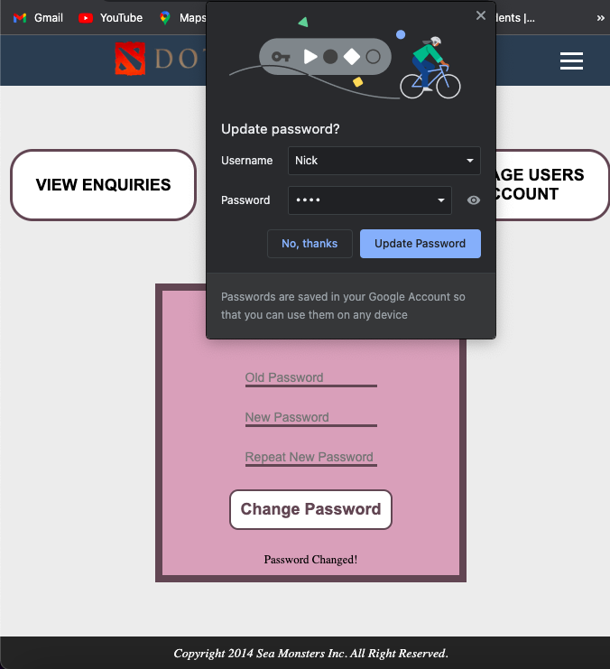

With the functions implemented in change_pw.inc.php, users will be able to change their passwords successfully if their inputs met the specific requirements and a “Password Changed” message will be displayed, showing them the password has been changed.

**3.1.2 Deleting**

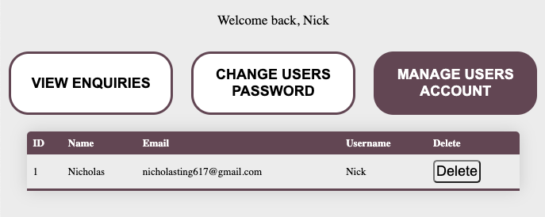

At the user.php page, users are able to view their information in a table format similarly to view_enquiry.php whereby it provides the table of enquiries. At the last column of the table, there is a button called “Delete” which upon clicking it, it will display dlt_confirm.php whereby it prompts the user to confirm in deleting their account.

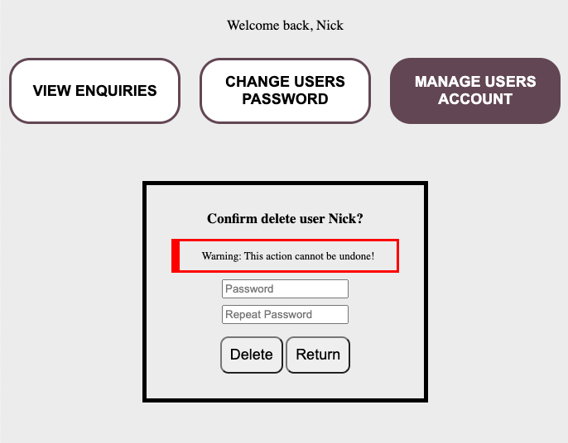

After the users key in their respective password in dlt_confirm.php, they may proceed in deleting their account by clicking on the “Delete” button. If not, they may click on the “Return” button which will lead the users back to the user.php page.

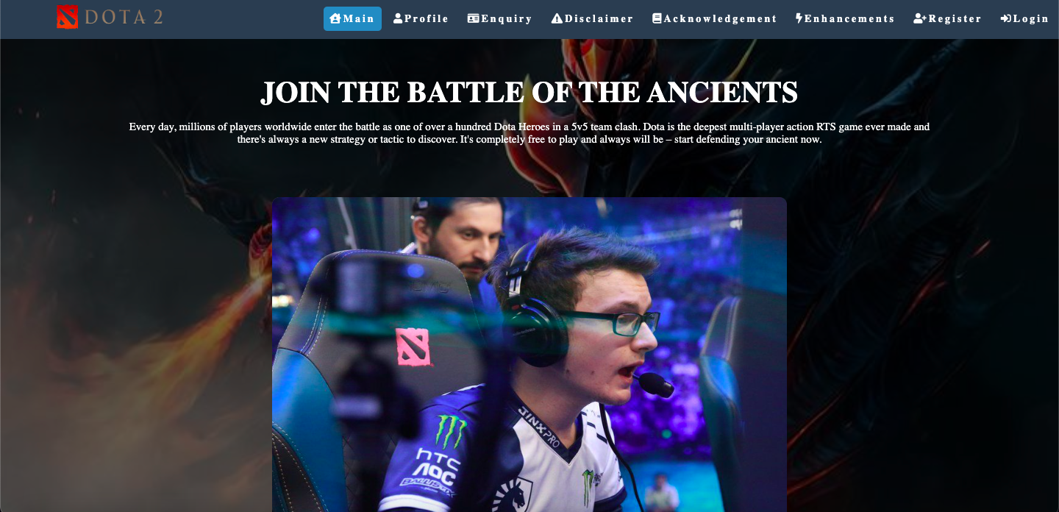

After clicking “Delete” when the password has been inputted, the user will be brought back to the initial main page of the website. This deletion process will also delete the data that was stored in the MySQL database as shown below.

